Title: working title

date TBA

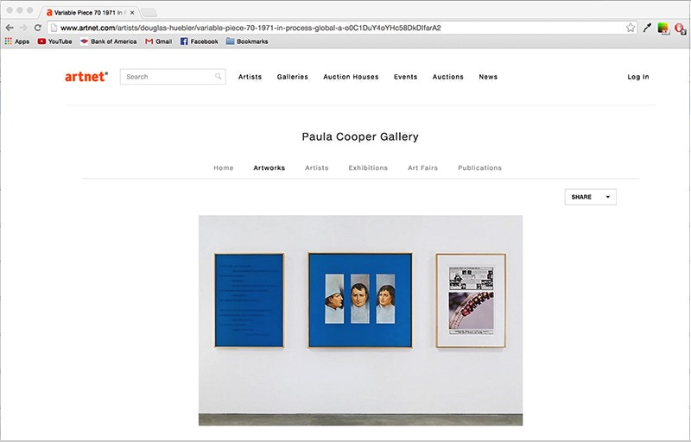

Format:

The performance will run on one 10am-6pm Sunday. The piece will begin with the install of a Douglas Huebler drawing that I have recreated in colored pencil and there will be a dance audio track that will be set up and played on loop for the duration of the performance. This music player will sit on a pedestal in opposition to the drawings. I will have cash either bundled or loosely spread out near particular items.

The project will be the collapse of the install, show, and deinstall elements, similar to my cleaning performance at Human Resources in 2013. I will begin by preparing and cleaning the gallery, then hanging the work. I will finish by removing the artwork, patching and repairing holes, cleaning and closing up the space. The performance will be performed solo and consist of myself working. I will be able to converse and communicate if needed but will clearly have a task ahead of me. The casualness of the event is something that is important to me.

Idea:

Art > Money > Death

The Huebler image is taken from one of his Variable Pieces. It is of Napoleon Bonaparte’s face shown three times from different angles, displayed in a triptych. I initially mistook the image for a chef and this misinterpretation of an artwork speaks to a loss of control and an artist’s lack of authority over an image he/she produces. I examine this array of male characters – Napoleon, someone entered into western history, the occupation of a chef which has typically been a male role, and Huebler, a conceptualist artist well-known within the arts but not to the rest of the world.

Money will be displayed as close to items such as the audio and the drawings as possible. The amount of cash will be based off of what the cost of production each item amounted to. During the performance the money may get stepped on or moved around several times for cleaning.

The audio component will be a dance track that will get turned on during the performance and be on loop. Performance is the ideal medium for this project as it forces the audience to be aware that an activity is happening in the present. The audio will aid this as well as create an eventual bookend when I turn off the sound source. The sound will speak to a sort of frenetic energy, mimicking the shared reality that the audio will end and that death, or ceasing to exist, is something we all innately fear.

Materials: (I have these items)

Clear Tarp

Ladder

Painters Tape

Paint

409

Windex

Spackle

Rags

Paper towels

Ruler and Level

Music Player

Pedestal for the audio to sit on

Broom, dust pan, mop

Access to water

Nails, drill, hanging equipment

Trash bags

Example from the performance at HR:

https://vimeo.com/83353881